1 INTRODUCTION
1.1 Overview
Professional business cards
1.2 Purpose
We created it for thr students to Learn PHONETICS on the go.
2 Problem Definition & Design Thinking
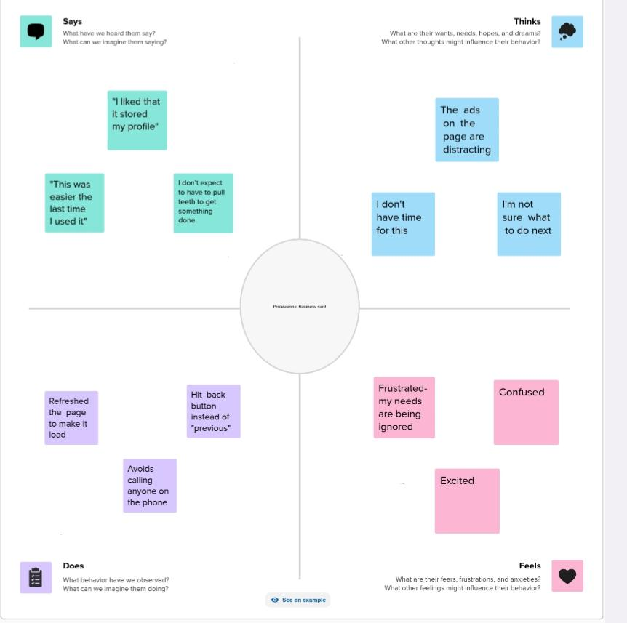
2.1 Empathy Map

2.2 Ideation & Brainstorming Map
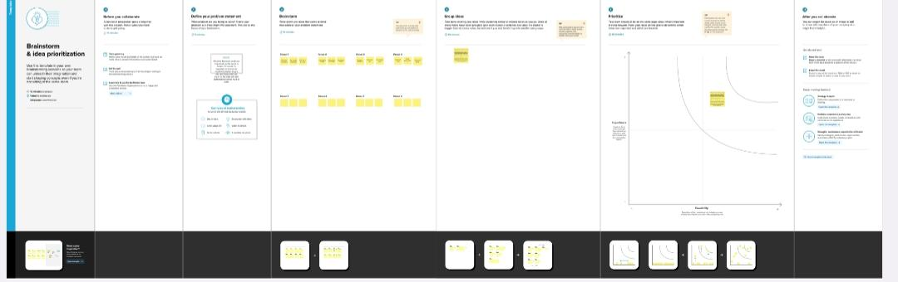

3 RESULT
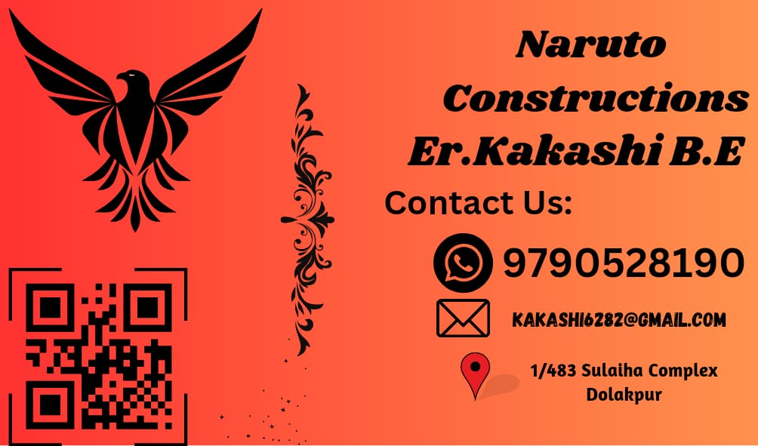

4 ADVANTAGES & DISADVANTAGES
It is useful for all the non-native English Speakers to Learn the Proper
Pronunciation on the Go.
Its disadvantage is , it doesn’t have the Practical Session.
5 APPLICATIONS
It is so much useful for the students and non native English Speakers
to Learn Proper Pronunciation.
6 CONCLUSION
We Learn a lot of New things about Editing and make it useful for

